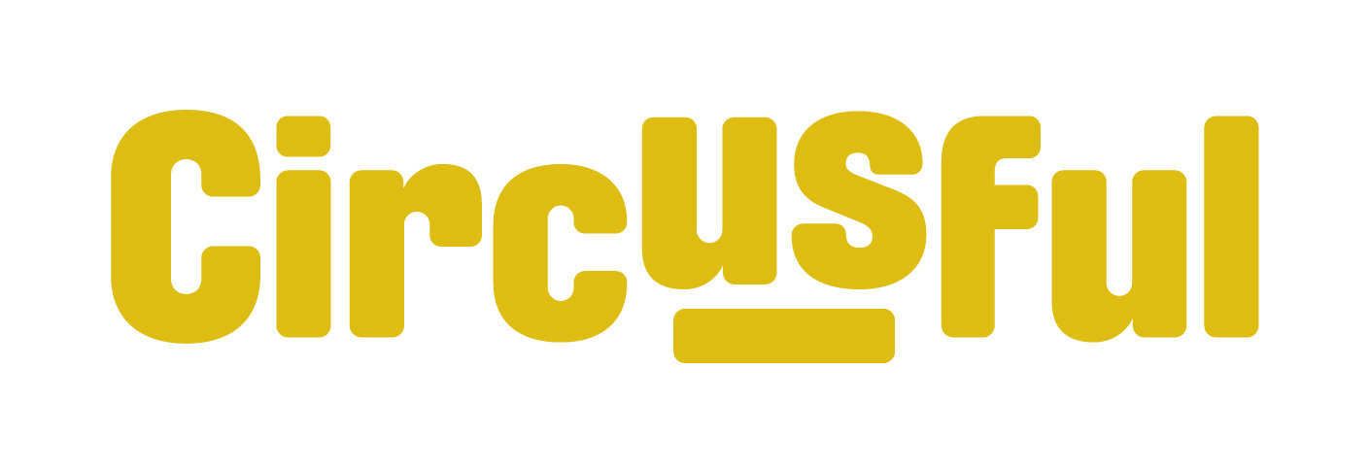
Summer Program 2022, for 2-18 year olds
Have a look at all the Itty Bitty and Youth circus classes we’re offering in July and August!
We think there’s something to suit everyone, but places are limited and will be allocated on a first come first served basis. To reserve a spot for your young person, send an email to classes@circusful.org with their name and age and let us know which class they’d like to attend. If there’s a place available, we’ll email you with more information. If the class is already full, we’ll add their name to a reserve list and let you know if a place becomes available.
Please note: Fees are payable at least 7 days in advance to secure their place.

Firstly - Some new and exciting one-off specials!

Acro Special with Hands Down Circus - for 12 to 18-year olds
Learn acrobatics and pyramids with Belfast circus company Hands Down Circus. Try headstands, handstands, cartwheels, 2 highs, pyramids and more in this special 2-day course. Open to anyone with an active interest in acrobatics or some gymnastic experience, an open mind to working with new people and a willingness to try and push themselves and their skills in new directions.
Tuesday 16th and Wednesday 17th August | 2pm – 5pm | The fee for this course is £35

Film Project - for 12 to18-year olds
Do you want to create circus mayhem on screen with other young agents of chaos? Bring a packed lunch, circus skills and a bag full of circus tricks and explore circus on film with award winning circus artist turned film maker Ken Fanning from Tumble Circus.
Monday 8th – Friday 12th August | 10.30am -4pm daily | The fee for this week-long project is £90

Unicycle games session - for 8 to18-year olds
Calling all Unicyclists - if you can ride a unicycle comfortably - join this session and enjoy learning some group games and formations - a special one-off opportunity!
Monday 15th August | 10.30am -12pm | The fee for this class is £10

Itty Bitty Circus classes

Itty Bitty summer sessions - for 4 to 5-year olds
A chance for your little ones to have fun playing games while trying out some circus skills including juggling, acrobatics, balancing and more.
Sign up for week 1, week 2 or both. The fee for one session is £10
 |  | Time:
Week 1 | Saturday 30th July | From 10am to 11.30am
Week 2 | Saturday 6th August | From 10am to 11.30am

Family Circus classes – For family groups of 2, 3 or 4 to learn together
Experience the fun of circus in this class for children and their adults - open to all levels of ability. Try your hand at juggling, trapeze, tightwire and other skills, supported by our expert tutors. Suitable for ages 2-8 (older siblings are welcome) and their grown-ups!
Register for 2 sessions in July, 2 sessions in August, or all 4 sessions
 |  | Time: | Fee for 2 sessions
July sessions | Saturday 16th and 23rd July | From 10am to11.30am | 1 adult and 1 child £36.00  1 adult and 2 children £44.00  2 adults and 1 child £48.00  2 adults and 2 children £54.00  Please note: Children must be accompanied by at least 1 adult
August sessions | Saturday 13th and 20th August | From 10am to11.30am

Itty Bitty Circus Summer Schemes - for 5 to 7-year olds
Try your hand at all things circus - balancing, throwing, rolling, climbing. A week-long taster class for small circus stars in the making with lots of fun and games.
Two weeks to choose from. The fee for one week of classes is £65
 |  | Time:
Week 1 | Monday 1st – Friday 5th August | From 9.30am to 11am daily
Week 2 | Monday 22nd – Friday 26th August | From 9.30am to 11am daily

Youth Circus classes

Youth Circus Summer Schemes - for 8 to 16-year-olds
Roll up, roll up - These fun filled summer circus classes are suitable for beginners and regular attenders alike - a chance to play, learn something new and practice your skills with friends.
Two weeks to choose from.
 |  | Age group | Time: | Fee for 1 week
Week 1 | Monday 1st – Friday 5th August | 8-12 years | From 11.30am - 3pm daily (with a short break for lunch) | £90
 |  | 13-16 years | From 3.30pm – 6pm daily | £75
Week 2 | Monday 22nd – Friday 26th August | 8-12 years | From 11.30am - 3pm daily (with a short break for lunch) | £90
 |  | 13-16 years | From 3.30pm – 6pm daily | £75

Serious Circus - for 14 to 18-year olds
For those who are ready for more focused training - join us for 2 weeks of nonstop circusing!
Everyone will do a mix of tumbling, juggling/ diabolo and aerial in the morning sessions, followed by group pyramids with options for more specialised skill time. Everyday there will be a choice of Chinese pole (week one), tightwire (week 2), aerial, handstands or chair balance, as well as alternating days of flexibility and performance work, with options of unicycle and a range of manipulation skills.
Sign up for week 1, week 2 or both. The fee for one week of Serious Circus is £150
 |  | Time:
Week 1 | Monday 18th – Friday 22nd July | From 10am to 5pm daily
Week 2 | Monday 25th – Friday 29th July | From 10am to 5pm daily

Circus Re-boot – for 16 to 25-year olds
For current and ex Youth Circus members. Come and rekindle your love for circus, push yourself to new limits or just learn something new! This 16-25’s class will deal with a variety of skills, from all things manipulation, to floor acrobatics, handstands and aerial. You’ll leave with sore arms and a glow of self-satisfaction, guaranteed!
Come to one class or come to all! The fee for this class is £12 per session
5 classes in August | Tuesday 2nd, 9th, 16th, 23rd and 30th | 6.30pm to 8.30pm

